Technical Design Template

Team: | Phantom | ITN: | 2 |  |  | Solution Design
 |  | Pipeline(s):
  MH2

Solution Design 1
Pipeline(s): 1
1 Introduction 1
1.1 Link to Requirements Document 1
1.2 Requirements 1
User Story 1
2 Design Discussion 2
2.1 Use Case 2
2.2 Class Diagrams 2
3 Implementation 3
3.1 Files 3
4 Testing Considerations 8
5 Screenshots 9

Introduction
This is a web-based application used to manage the contacts for a firm. The contacts are stored in a secure location on an internal server and the user is able to log in to the system using their access details.
The user can perform CRUD operations based on the privileges provided to them by the administrator.

Link to Requirements Document
https://jira2.cerner.com/browse/DEVACDMY-5165

Requirements
.

User Story
User Story ID | MH2
Story | Add a new contact
Description | The user is able to enter new contact details which after validation can be added to the database.

Design Discussion

Use Case
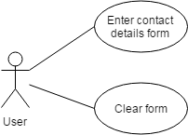
Figure 1 Use Case for adding new contact

2.2 Class Diagrams

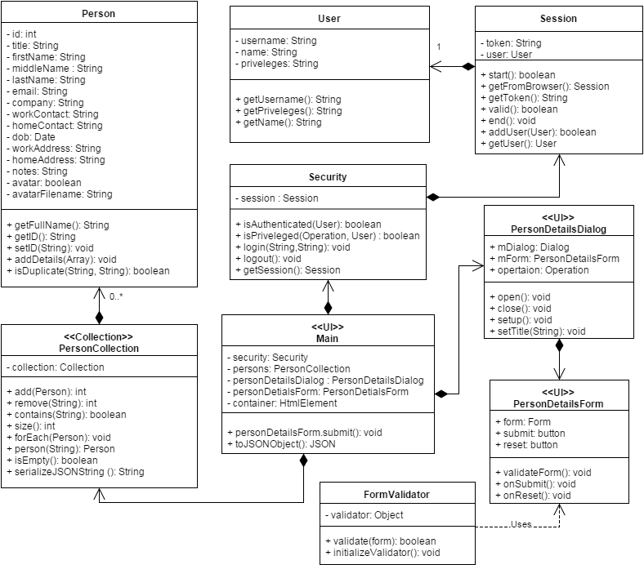
Figure 2 Class Diagram for adding contact

Implementation

This user story is to build a dialog form where the user enters the contact details to add to the database. The implementation details are as follows:

- The user can click on the add button to open a dialog form.
- The dialog form consists of fields that are mandatory and some are optional.
- The user enters the contact information using the keyboard.
- The jQuery validation plugin is used to validate the input given in the fields.
- The validation rules are as follows:
- The title, first name, last name, work contact and the email are mandatory fields while the rest are optional.
- Email address should be a valid email address.
- The work and home contact numbers should be digits and no letters.
- The date of birth should be in proper format.
- The notes field is incorporated to store any other relevant information about the person.
- The clear all button can be used to clear up all the fields and get a blank form.
- The validation functions are called upon the key up event of the keyboard and the focus out event of the html element. On clicking the submit button, the validation script is called on all the elements.
- The invalidated fields are marked with ‘error_msg’ class which is used by the css file to highlight those fields.

Files

3.1.1 HTML

File | listPersons.html
Description | This is the home page where the user lands after successful authentication. It is the dashboard fir the user to add, view, update and delete contact and their details.
Passive (Yes/No) | No

3.1.2 CSS

File | css/home.css
Description | It is the css file for the “home.html” page defines the styling for the various html elements.
Passive (Yes/No) | No

3.1.3 JAVASCRIPT

File | scripts/js/Main.js
Description | This class creates the objects for the application and sets up the click and submit events. It directly deals with UI elements to implement business logic.
Pseudo Code | personDetailsForm.submit(function(event){  //serialize form information into JSON  var personJSON = $(this).serializeObject();  //duplicate record check  var duplicateFound = false;  persons.forEach(function(person){  // do not compare with self record  if(person.id != personJSON.id){  if(person.isDuplicate( personJSON.email, personJSON.workContact)){  duplicateFound = true;  }  }  });  if(duplicateFound){  //show a that given email/workContact already exists  $('#message').html(message);  }else{  var personObj = new Person(personJSON.id);  personObj.addDetails(personJSON);  persons.add(personObj);  personDetailsDialog.close();  }  //repopulate list  populatePersons(persons, container, personDetailsDialog );  });

File | scripts/js/PersonDetailsDialog.js
Description | This class is the representation of the html dialog on the UI.
Pseudo Code | function open (){  this.mDialog.dialog('open');  }  function close(){  this.mDialog.dialog('close');  }

File | scripts/js/PersonDetailsForm.js
Description | This class is the representation of the html form on the UI.
Pseudo Code | function reset (){  this.resetForm();  this.formValidator.removeErrorMessages();  $('.ui-state-highlight').removeClass('ui-state-highlight');  $('#message').html('');  }

File | scripts/js/FormValidator.js
Description | This class is the form validator that validates the data entered by the user into the input fields.
Pseudo Code | class FormValidator = {  function initializeValidator(){  $.validator.setDefaults({  highlight: function(input) {  $(input).addClass("ui-state-highlight");  $(input).addClass("ui-element-state-error");  },  unhighlight: function(input) {  $(input).removeClass("ui-state-highlight");  $(input).removeClass("ui-element-state-error");  },  errorClass: 'error_msg',  wrapper : 'td',  errorPlacement : function(error, element) {  error.addClass('ui-state-error');  error.prepend('<span class="ui-icon ui-icon-alert"></span>')  var thirdCol = element.closest('td').nextAll('.third-col');  error.appendTo(thirdCol);//.effect('highlight', {}, 2000)  }  });  }  }
Passive (Yes/No) | Yes

File | scripts/php/Person.js
Description | This class defines the person object along with a function add the person details.
Pseudo Code | function addDetails (fields){  // for each key in array add to this['fieldname']  for(var field in fields){  if(fields[field] == null) fields[field]="";  this[field] = fields[field];  }  }

File | scripts/php/PersonCollection.js
Description | This class is an implementation of the Collection class. It is a collection of persons and defines functions that are required for a collection.
Pseudo Code | function PersonCollection(){  this.collection = new Collection();  this.add = function(person){  this.collection.add(person.getID(), person);  return this.collection.getCount();  }  this.remove = function(id){  this.collection.remove(id);  return this.collection.getCount();  }  this.contains = function(id){  return this.collection.contains(id);  }  this.size = function(){  return this.collection.getCount();  }  this.isEmpty = function(){  return this.collection.isEmpty();  }  }

File | scripts/js/User.js
Description | This class is the definition of a real-user of the application and contains user-related info like username, name, privileges etc.

File | scripts/js/Session.js
Description | This is the class that store the current session and the user associated with the session
Pseudo Code | function valid(){  request = new Request();  validateSessionEventHandler = new RequestEventHandler();  coordinator = new UICoordinator();  coordinator.sendRequest(req, validateSessionEventHandler );  if(validateSessionEventHandler.success)  return true;  else  return false;  }  }

File | scripts/js/Security.js
Description | This class is responsible for authentication and validating session and privileges. It sends a request to the server for login() and logout() respectively
Pseudo Code | function isAuthenticated(user){  if(user.session == null) return false;  else{  return user.session.validate();  }  }  function isPriveleged(operation, user){  switch(operation){  case Operation.FETCH_LIST:  case Operation.FETCH_DETAILS:  case Operation.READ:  if(user.priveleges.search('r') != -1) return true;  case Operation.ADD:  case Operation.EDIT:  case Operation.DELETE:  if(user.priveleges.search('w') != -1) return true;  default:  return false;  }  }

Testing Considerations
Navigate to the listPersons.html and follow the steps given below for each test case.

#Test Cases | Test Steps | Expected Results
TC 1 | - Click on the add button | A dialog window appears with a form to enter contact details.
TC 2 | - Click on the add button  - Click on the submit button | The required fields are highlighted and the user is asked to fill up these details
TC 3 | - Click on the add button  - Enter less than three characters in the first name field | An error message displays saying “Please enter atleast three characters”
TC 4 | - Click on the add button  - Enter an invalid email address | An error message displays saying “Please enter a valid email address.”
TC 5 | - Click on the add button  - Enter an invalid date in dob field | An error message displays saying “Please enter a valid date.”
TC 6 | - Click on the add button  - Enter alphabets in work contact or home contact. | An error message displays saying “Please enter only digits.”
TC 7 | - Click on the add button  - Fill up the required fields appropriately  - Click on ‘Clear all’ button | The form inputs are cleared and the form is reset

Screenshots

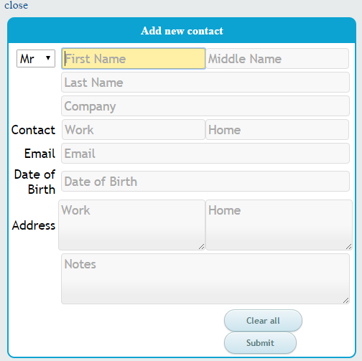
Figure 3 Dialog form to add new person

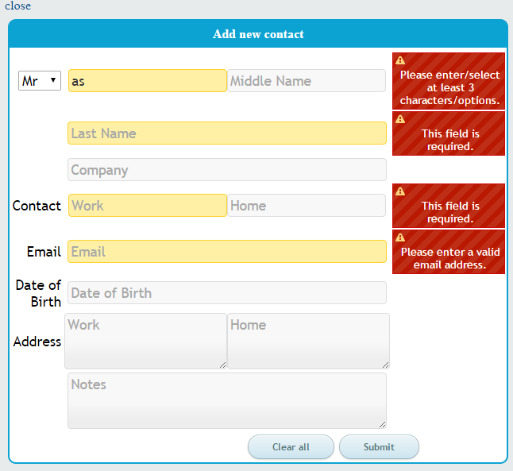
Figure 4 Validation script in action on the dialog form

